24th October 2017

**YOKOHAMA Announces “BluEarth-air EF21”, A Lightweight, Fuel-Efficient Tyre**

YOKOHAMA today announced the development of the “BluEarth-air EF21”, a conceptual tyre based on the most advanced technologies and the latest design technique for reducing tyres’ weight and environmental impact. Developed to commemorate the Company’s 100th anniversary, the new tyre will be marketed in Japan on a limited basis this year in one developmental size, 205/55R16 91V.   
  
Seeking to create a more environmentally friendly tyre, YOKOHAMA has employed its latest design technique to achieve a lighter tyre that conserves resources by using less material and improves fuel efficiency by contributing to lighter overall vehicle weight. In addition to being light, the BluEarth-air EF21 has achieved a thin yet highly rigid structure and a weight reduction of about 25% in the tyre’s mass.* The tyre also achieves excellent wet and fuel-efficient performance from the use of a newly developed special compound and YOKOHAMA’s state-of-the-art rubber mixing technology, Advanced Reaction Technology in Mixing. In addition, the BluEarth-air EF21 has received a “AAA” grade for rolling resistance and an “a” grade for wet grip performance, the highest grades awarded under Japan’s tyre labeling system.  
* Compared with the ADVAN dB V551, the YOKOHAMA tyre considered to be the Company’s standard for tyre mass.  
  
The BluEarth-air EF21 will be introduced to the world at the YOKOHAMA booth at the upcoming 45th Tokyo Motor Show 2017, to be held at the Tokyo Big Sight from 25th October to 5th November (open to the general public from 28th October).   
  
BluEarth is a YOKOHAMA global tyre brand based on the concept of “environmentally, human, and socially friendly”. Other tyres in the BluEarth brand include BluEarth-A, which combines excellent wet performance with high fuel efficiency; the BluEarth RV-02, a fuel-efficient tyre for minivans and CUVs; and the BluEarth-Es, a fuel-efficient standard tyre.

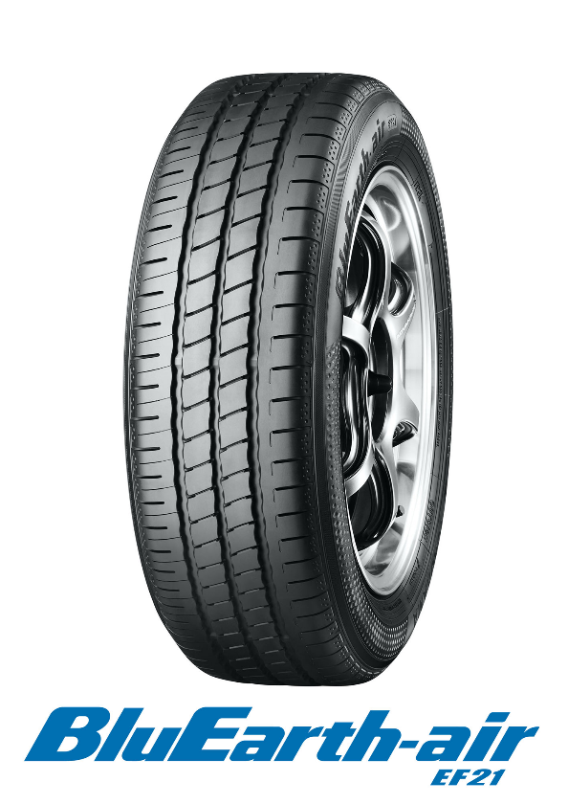

*BluEarth-air EF21*